**Assignment3: Create V-net, Subnet, NSG and by using this**

1.How to Create VM

2.How to Create snapshot-VM

3.How to Create image-VM

**1.How to Create VM**

**Creating V-net and Sub-net:**

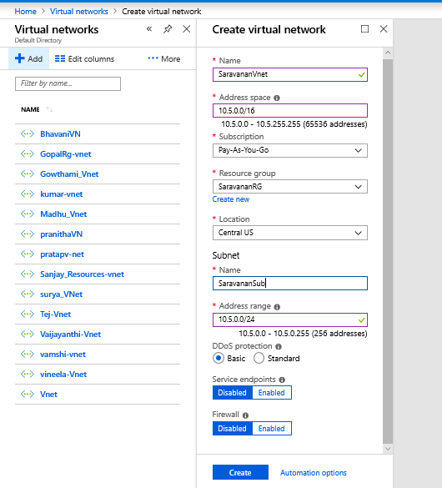

**Created NSG:**

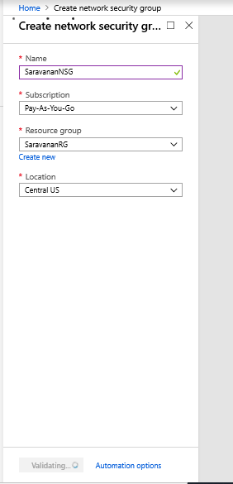

**Creating VM:**

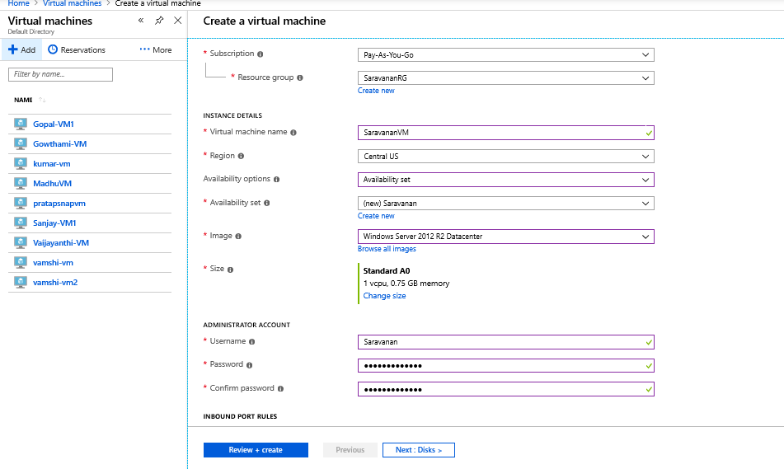

**Created VM Disk:**

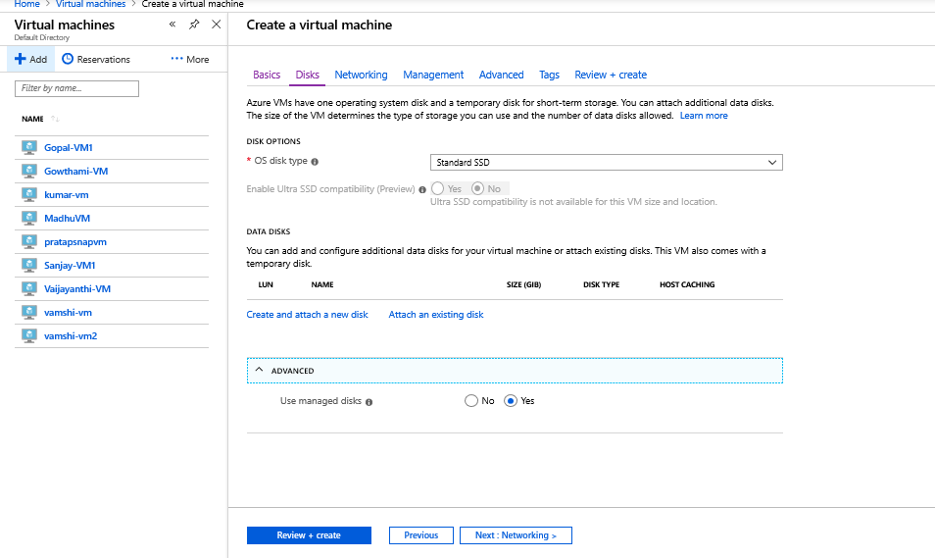

**Created VM Management:**

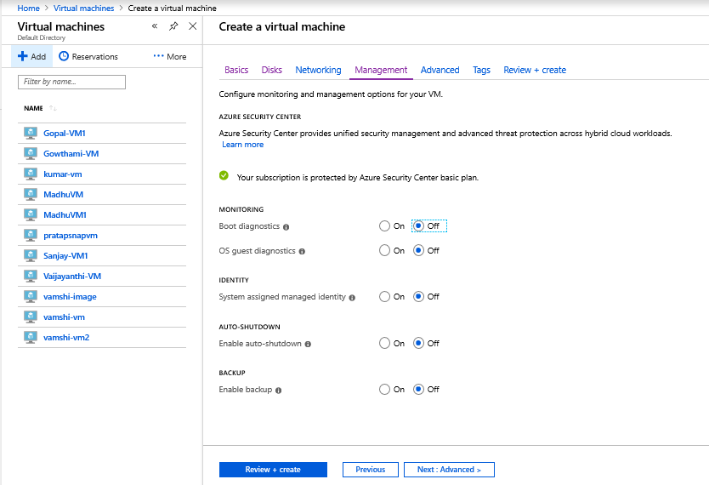

**Created VM Network:**

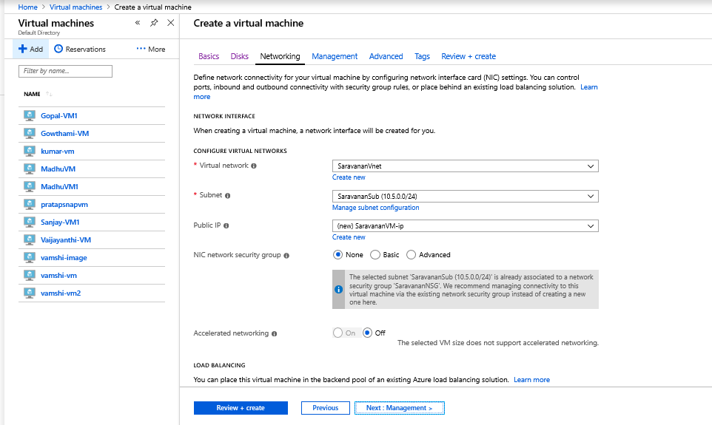

**VM Review:**

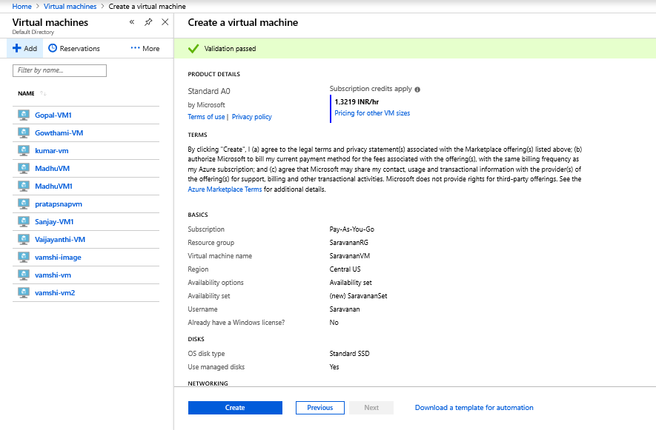

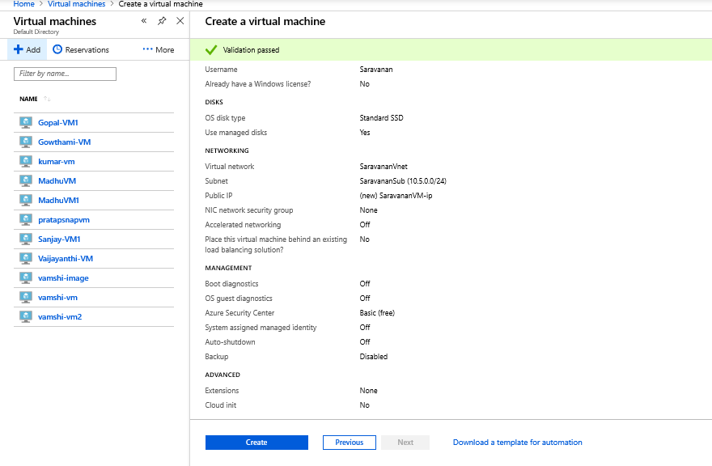

**Created Snap in VM:**

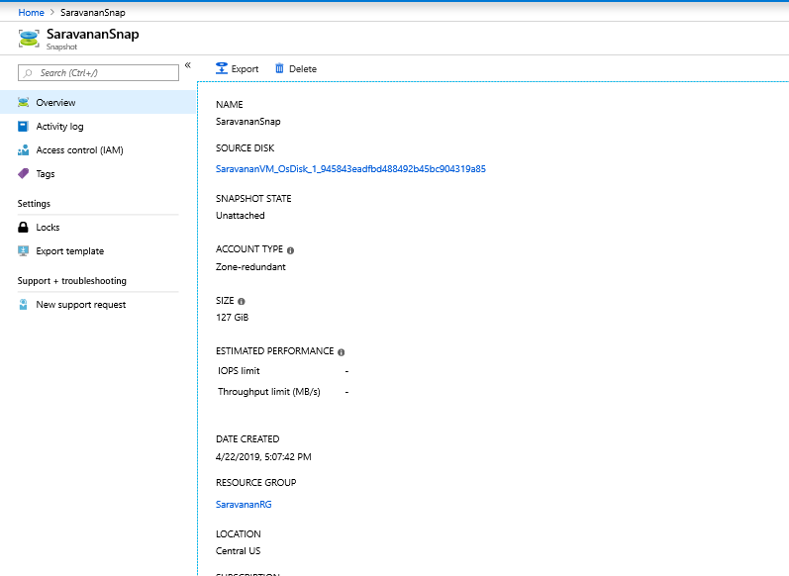

**Created manage Disk:**

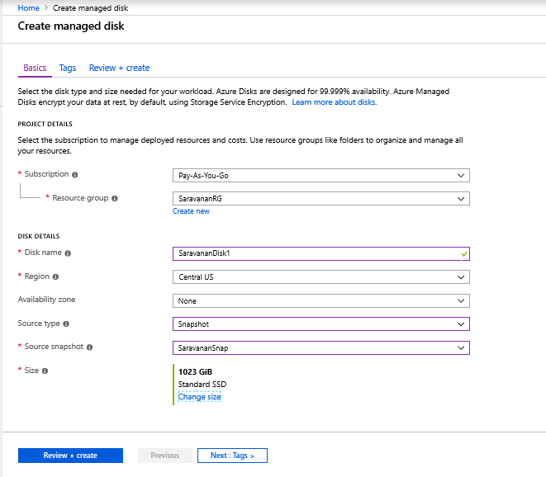

**Snapshot Disk Added to new VM:**

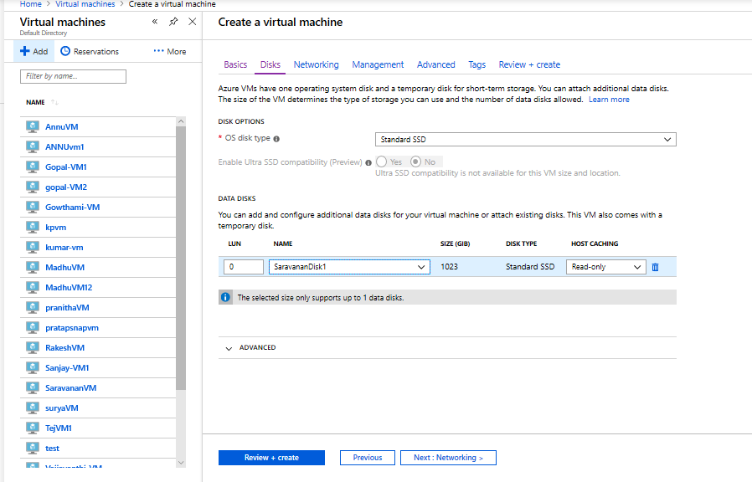

**Review of newly created VM:**

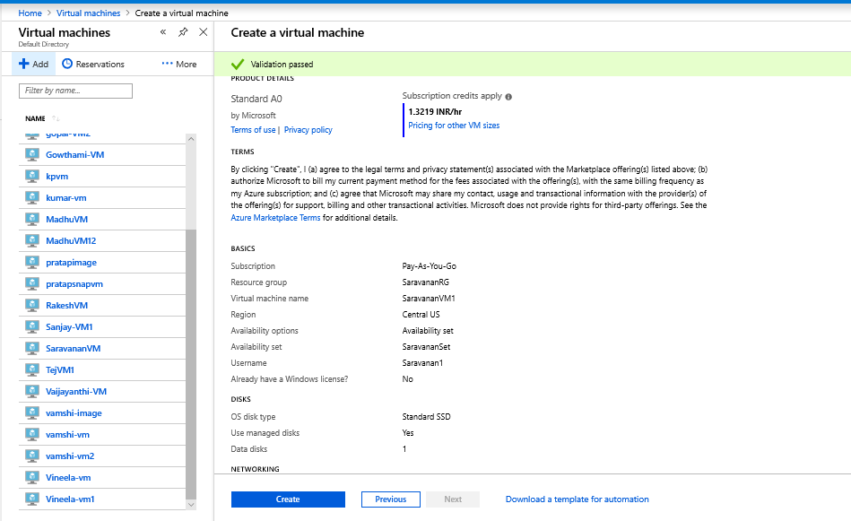

**Created image for new VM:**

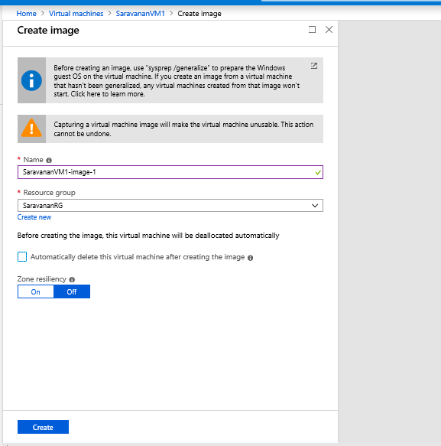

**VM Connected local machine with help of  RDP and imaged that VM:**

